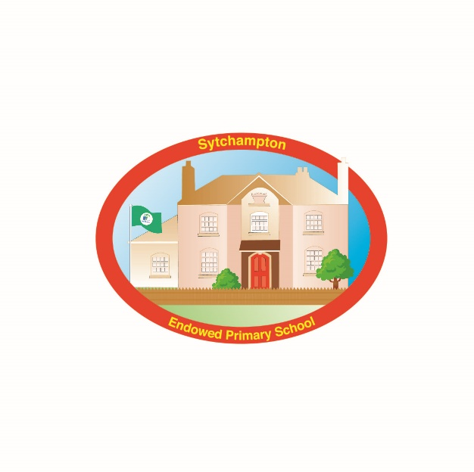Sytchampton Endowed Primary School

**Notes regarding Consents**

**Media Consent**

To celebrate school events we often send press releases to local newspapers and also like to put photographs on the school website to give a flavour of the events taking place at school. We would also like to display children’s work around school, and offer your child the chance to have annual formal individual and group photographs taken.

Please be advised that Sytchampton Primary School does not give permission for any photographs or filmed footage taken by parents, carers or visitors to be placed on any internet or social networking sites. We allow film and photographs to be taken at plays and events on the understanding that the above policy is respected.

We have social media accounts to keep parents and the community informed of what is going on at Sytchampton Primary School - if you would like to follow us please search Twitter for **@sytchampton**, and our Facebook page is **Sytchampton Endowed Primary School.**

The school cannot be responsible for the “suggestions” or “recommendations” on these social media sites as some content is not controlled by us. We are also obviously not responsible for any content or links that might be visible or accessible through parent/carer/follower profiles. We therefore strongly advise parents/carers to supervise their children’s access to Twitter or Facebook and if you are going to show your child the feed, then please take a preview and check the “up to date news feed” beforehand.

We are also asked at certain events or visits whether our children can be featured on social media pages run by other parties, so our consent form also asks you to confirm if you give permission for this too.

**Food Tasting**

At Sytchampton Endowed Primary School, children are involved in testing and tasting food in a number of subjects often linked to our topics.

We require consent so that your son/daughter can taste or handle any types of food, and must be made aware of FULL details of any allergies or food intolerances that your child has.

If your child develops an allergy or intolerance during the school year please ensure that the school office is informed immediately.

**Forest School Walks**

At various times during the year, our children are offered sessions at our Forest School.

For the sessions your child should come to school dressed appropriately for Forest Schools - old trousers, coats, waterproofs and wellies with usual school polo shirt and sweatshirt/cardigan. They should bring the rest of their uniform with them, **in a named carrier bag please,** to change into after the session, as they are likely to get wet and muddy.

As part of the Forest School sessions (and also for other learning opportunities in school) we spend time in and around our school grounds and also go for short walks along the lane behind school.

**If your personal circumstances change at any time please inform the school accordingly.**

**You have the right to withdraw your consent to any of the above at any time – please advise the school office.**