Science Learning Sequence

Year Group/Class: Oak  Term: Autumn 2 | Topic: Electricity  Identify common appliances that run on electricity.  Construct a simple electrical circuit
Prior Knowledge/Teaching: (What does this unit build on?)  Year 2 have not previously covered electricity.  Year 1 covered last year in Reception – explore how things work | Threshold Concepts:  Working scientifically  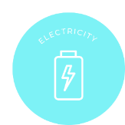  Physics
Key Vocabulary:  Electricity Circuit  Mains Battery  Power Appliance  Wire  Battery  Component | Learning Lenses:  