Basic Principles – What is Learning?

Learning is a process.

We understand that learning is a change to long-term memory.

We accept that learning cannot be observed in the here and now. The only way to see if something has been retained over time and transferred to a new context is to look at what students can do elsewhere and later. Cognitive development happens gradually and by increments

Our aims are to ensure that our students experience a wide breadth of study and have, by the end of each key stage, long-term memory of an ambitious body of knowledge.

Our Curriculum Intent Model
Identifying our Curriculum Drivers
Curriculum drivers shape our curriculum breadth. They are derived from an exploration of the backgrounds of our students, our beliefs about high quality education and our values. They are used to ensure we give our students appropriate and ambitious curriculum opportunities. The Curriculum Drivers which underpin and shape our Curriculum at Sytchampton are Resilience, Risk Taking and Independence.
Cultural Capital
Cultural capital gives our students the vital background knowledge required to be informed and thoughtful members of our community who understand and believe in British values. Our community lacks diversity and it is important that our Curriculum at Sytchampton allows our pupils to explore the diverse world around them, considering a range of different cultures, beliefs, disabilities and relationships. Our pupils also need to develop resilience and have the courage to take measured risks.
Curriculum Breadth
Curriculum breadth is shaped by our curriculum drivers, cultural capital, subject topics and our ambition for students to study the best of what has been thought and said by many generations of academics and scholars. We ensure that all of our pupils have equal access to all subject areas throughout their time at Sytchampton.

Our Curriculum Design
Rationale
We have considered a range of Cognitive Learning research before considering how to design our curriculum. Consequently, we decided that our curriculum should be designed to help our pupils form a schema within their long-term memories.
Schema theory states that all knowledge is organised into units and is a conceptual system for understanding and organising knowledge in a meaningful way.
A schema is distinct from information, which is just isolated facts that have no organisational basis or links. We have developed a curriculum which:
- Uses Threshold Concepts as the basis for the schema
- Strengthens the schema with knowledge
- Deepens connections

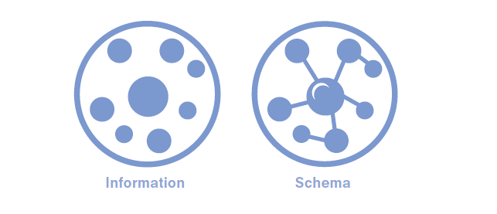

Threshold Concepts
Threshold concepts are the ‘Big Ideas’ that underpin a subject.
Threshold concepts tie together the subject topics into meaningful schema, thereby enabling pupils to retain knowledge in the long term. The same concepts are then explored in a wide breadth of topics. Through this ‘forwards-and-backwards engineering’ of the curriculum, students return to the same concepts over and over and gradually build understanding of them over time.

So for example, building a schema for pupils in History would look something like this:
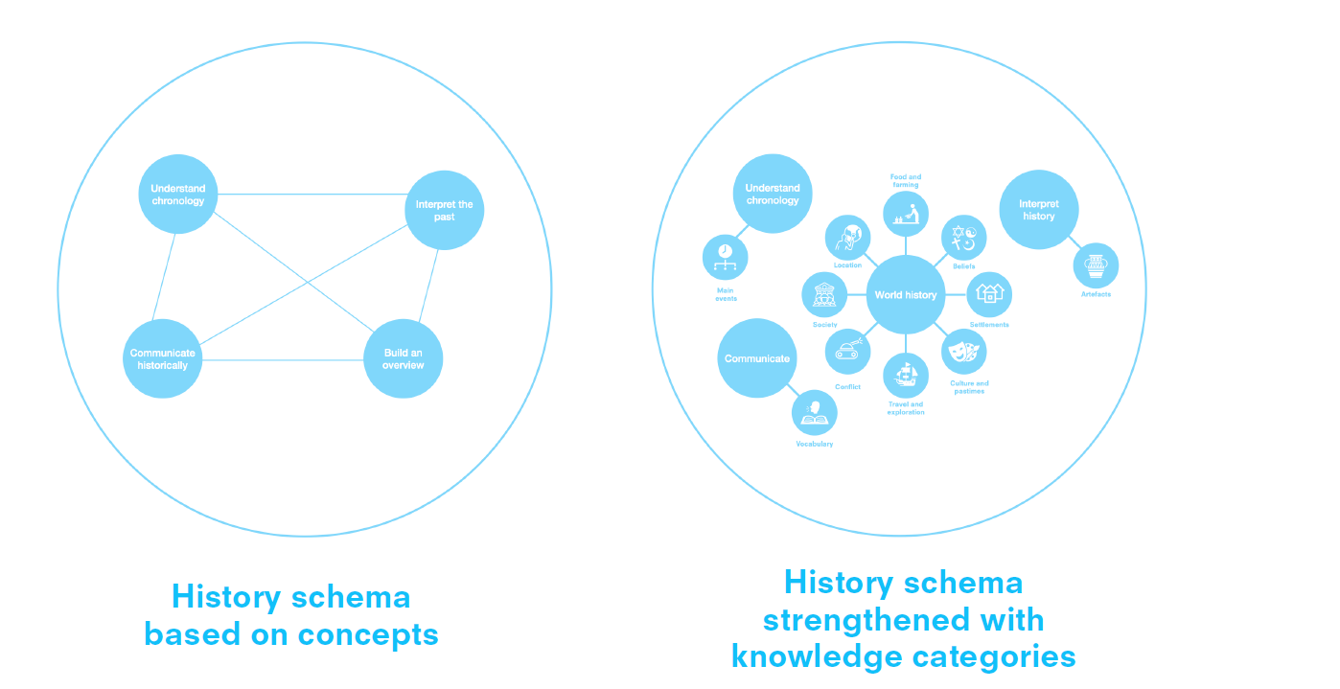
Progression of Threshold Concepts
For all subject areas, we have mapped out the progression of skills and knowledge for each Threshold Concept.
Learning Lenses
We have developed Learning Lenses for all of our foundation subjects. These are effectively the knowledge categories in each subject. These are referred to explicitly within our lessons.
Our Learning Lenses are the facets of each Threshold Concept and these lenses help to strengthen the schema. For example in Geography we have identified the following learning lenses:
For every Foundation Subject, one learning lens is a focus on key vocabulary, which is taught explicitly and then embedded across the learning sequence and referred to frequently. This Key Vocabulary is mapped out for all subjects within our Vocabulary Spine (see separate document). 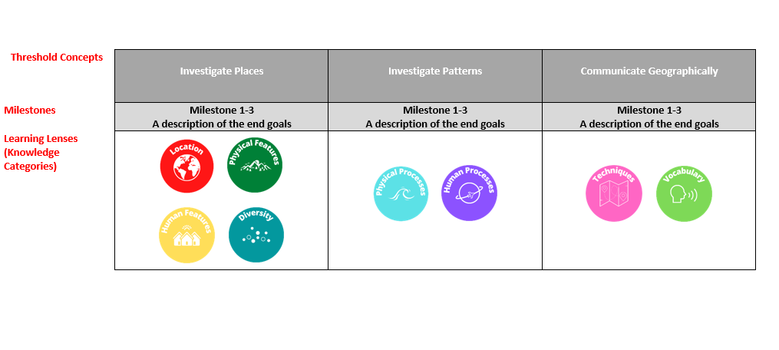

The Spiral Curriculum
The Spiral Curriuclum is a method of designing a course of work around basic yet fundamentally important and recurring themes (Threshold Concepts) in a discipline.
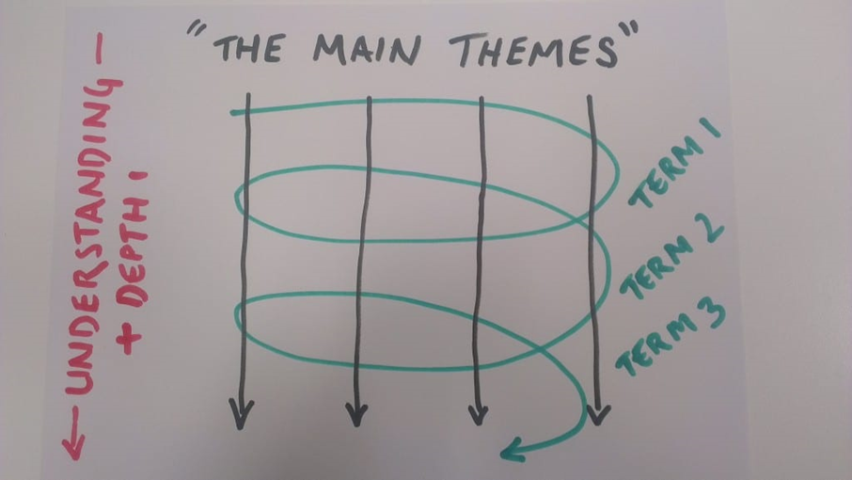
We have developed Learning Pathways for our Foundation Subjects to ensure that our pupils’ learning revisits Threshold Concepts repeatedly throughout their time in our school. By doing this, pupils will be able to strengthen their schema, adding new knowledge to previously taught concepts.
Mixed Year Groups
Due to the size of our school, we have mixed year groups in Years 1 and 2, 3 and 4 and 5 and 6. We group these as follows:
Key Stage 1 (KS1) Years 1 and 2
Lower Key Stage 2 (LKS2) Years 3 and 4
Upper Key Stage 2 (UKS2) Years 5 and 6
Designing a spiral curriculum which is sequential and builds on prior knowledge is challenging in a Mixed Year Group school. Therefore, we have carefully designed Learning Pathways for all of our Foundation Subjects, in all year groups alternating between Year A and Year B.
Academic Year | Teaching Year (A or B)
2021 – 2022 | Year A
2022 – 2023 | Year B
2023 – 2024 | Year A
2024 – 2025 | Year B

We have endeavoured to map our Curriculum so that there is a clear progression within each Key Stage, but also within and across each Teaching Year.

Learning Pathways
Our Learning Pathways show how we have mapped our Threshold Topics and/or our Key Topic Areas across the whole school for each subject area:
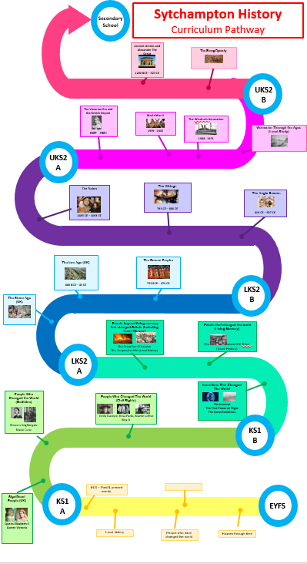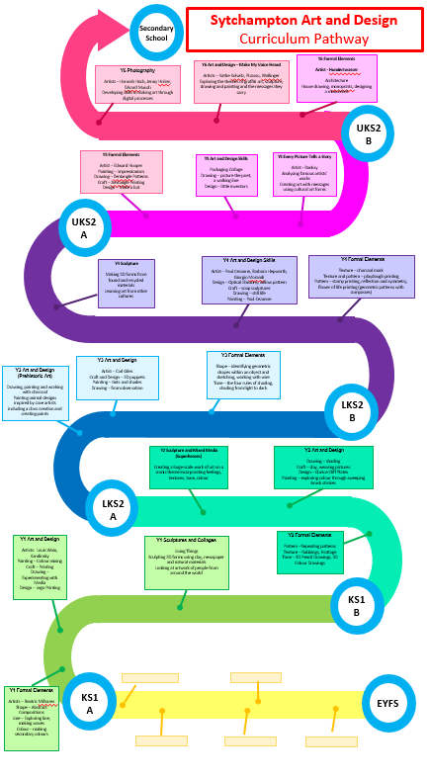

Timetabling
We have decided, that in order to ensure our pupils are regularly revisiting Threshold Concepts and subject specific vocabulary, that a number of subjects will be taught on a weekly basis:
English | KS1 | KS2
Writing sessions | 45 mins Mon to Fri  Alternating technical skills with application on a two week basis | 45 mins Mon to Fri
Reading | Hooked on Books – 5 sessions over a two week period  Remaining sessions Buddy Readers and Individual Reading | Hooked on Books – 5 sessions over a two week period
Phonics | 4 x 30 minutes per week, then applying in technical sessions fortnightly
Spelling and Grammar | Spelling Test 30 mins Fridays | Spelling Test 30 mins Fridays
Handwriting | 08.50 – 09.00 as pupils come into school/registration  1 taught session every fortnight | 08.50 – 09.00 as pupils come into school/registration  1 taught sessions per week (20 mins)
Class Read | Books in Assembly  Buddy Reading | Books in Assembly  Buddy Reading

Subject | KS1 | KS2 | Schemes Used
Maths | 5 hours per week (combination of 45 minute sessions, 15 minute fluency sessions and timestables tests) | 5 hours per week (combination of 45 minute sessions, 15 minute fluency sessions and timestables tests) | White Rose  NCETM
Science | 45 minutes weekly | 45 minutes weekly | Essentials Curriculum (Chris Quigley)
Computing | 45 minutes weekly | 45 minutes weekly | Teach Computing
Physical Education | 90 minutes weekly | 90 minutes weekly | The Power of PE  External Specialists
Religious Education | 60 minutes weekly | 60 minutes weekly | Worcestershire Agreed Syllabus
PSHE/RSE | 45 minutes weekly | 45 minutes weekly | KAPOW
Music | 45 minutes weekly (Specialist Teacher) | 45 minutes weekly (Specialist Teacher)
French |  | 30 minutes weekly | PlanIt
History/Geography | 90 minutes per week on a half termly rotation (A and B half terms) | 90 minutes per week on a half termly rotation (A and B half terms) | Essentials Curriculum (Chris Quigley)
Art/DT | 90 minutes per week on a half termly rotation (A and B weeks) | 90 minutes per week on a half termly rotation (A and B weeks) | KAPOW

History/Geography/Art/DT rotation:
 | Autumn 1 | Autumn 2 | Spring 1 | Spring 2 | Summer 1 | Summer 2
Geography |  | √ |  | √ |  | √
History | √ |  | √ |  | √
DT |  | √ |  | √ |  | √
Art | √ |  | √ |  | √

Curriculum Recording
We have discussed, as a staff, how to best record evidence of learning and progression, without creating unnecessary workload. Work is recorded as follows:
EYFS
Supported Writing | Yellow Books
Handwriting | Red (half blank, half lined)
Number | Blue (Blank for maths jottings)
EYFS Curriculum | Evidence Me and Seesaw (photographic evidence)  Floorbooks

 | KS1 | KS2
Literacy | Yellow book | Yellow book
Maths | Blue book (squared) | Blue book (squared)
Handwriting | Red (normal lines) | Green (Handwriting lines)
Humanities (History/Geography) | Green books | Green books
Science | Purple books | Purple books
Art | Sketch books | Sketch books
PSHE/RE | Red book | Red books
French |  | (Whole of KS2)
Computing | Digital records (pupil share)  Floor books | Digital records (pupil share)  Floor books
Design and Technology | Floor books | Floor books

